Link mechanism simulator

manual

This manual is translated from Japanese using machine translation.

This application will start in the display language according to the language setting of the browser (language setting that can be obtained with "window.navigator.language").
You can explicitly change the display language by adding "lang=ja" or "lang=en" to the parameter (eg linksim.html?lang=en).
By customizing “js/linksim-lang.js”, it is possible to display in languages other than Japanese and English.

Summary
The "Link Mechanism Simulator" simulates the movement of parts that have power and rods and other parts connected to them. Various parts can be freely placed on the screen with mouse operation.
In addition, the created link mechanism model can be saved and printed as a still image, and can also be output as a GIF animation.

Note that the current version of the "Link Mechanism Simulator" does not support the following link structures.
(Mechanisms not supported in the current version)
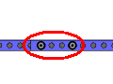
A mechanism in which two parts are connected by multiple movable pins

In addition, since this "link mechanism simulator" is written only in JavaScript, it can be installed in an environment where an HTTP (S) server is running. (The function of uploading teaching material data requires a script execution environment on the server side, but various servers - Multiple server-side languages (PHP, ASPX, PERL, PYTHON) are supported to support the environment. ）。

Launch
〇 Simple startup
- Start by opening dccs.html.
〇 Load data at the same time as startup
- Start "linksim.html" as "linksim.html?data=(link mechanism name)".
* When the link mechanism data is uploaded to the server's data folder.

Menu
Start-up screen
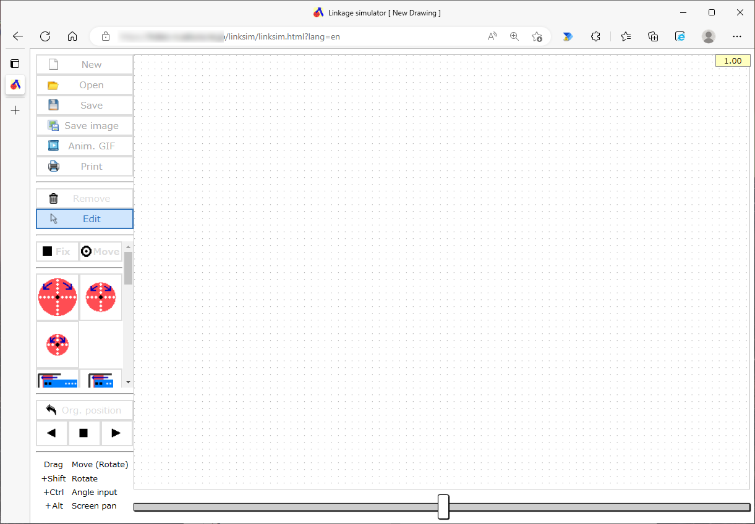

Processing Menu

Parts Menu

Operation Menu

〇 Processing menu
New
Clears the mechanism data being edited and sets it to the startup state.

Open
Open and view the mechanism data file.

Save
Save the feature data to a local file.
The save destination depends on the browser settings, and if a file with the same file name exists in the save destination, a branch number such as (1) will be added depending on the browser function.

Save image
Save the mechanism diagram displayed on the screen to a local file in the form of a PNG image.
The save destination depends on the browser settings, and if a file with the same file name exists in the save destination, a branch number such as (1) will be added depending on the browser function.

Anim. GIF
Saves the operation of the mechanism diagram displayed on the screen to a local file in animated GIF format.
When saving, you can specify the size and playback speed of the animation.
The save destination depends on the browser settings, and if a file with the same file name exists in the save destination, a branch number such as (1) will be added depending on the browser function.

print
Print the mechanism diagram displayed on the screen.

〇 Parts menu
Remove
Remove a part on the mechanism diagram.
Select the [Remove] button and click the part on the mechanism diagram to remove it. After deleting parts, the Edit button is selected.
You can remove parts consecutively byholding down the Ctrl key and clicking on them.

Edit
You can edit the position movement and angle of parts on the mechanism diagram.
You can also hold down the Alt key while dragging to pan the entire schematic.

Parts
Place the part on the mechanism diagram.
Select each [Part] and click on the mechanism diagram to place the part on the mechanism diagram. After placing the part, the [Edit] button is selected.
By holding down the C trl key and clicking, you can place them continuously.
Multiple power components cannot be placed on the mechanism diagram.
(Usable parts)
Power components | Power disk: Rotates around a fixed pin.
 | Power rod: The rod makes a rotational motion around the fixing pin.
 | Power piston: The piston reciprocates in the cylinder.
Connecting parts | Securing pins: Secure the part on the mechanism diagram.
 | Movable pins: Connect parts together.
Non-powered components | Disk: Rotates around a fixed pin.
 | Rod: Used to connect parts together. Four lengths are available.
 | Slide rod: The rod part moves with the pin fixed on the mechanism diagram.
 | Piston: The piston reciprocates in the cylinder.
 | Triangle: Used to connect parts together. Two sizes are available.
Pen | Draw the trajectory of the placement position on the mechanism diagram.

〇 Operation Menu
Run a mechanism diagram simulation.

Editing a Mechanism Diagram

〇 Moving parts
You can translate parts that do not have pins connected by dragging them.
You can rotate around the pin by dragging the part to which the pin is connected.
If a component is connected to another part and has only one pin placed, it can be rotated around that pin by dragging (the part (1) in the following figure is rotated), and by dragging while holding down the Shift key, it can be rotated around the pin of the connected part ( The component (2) in the following figure rotates).
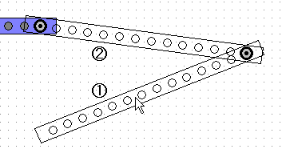

When you click a rotatable part while holding down the Crtl key, the following dialog box appears, allowing you to rotate at a specified angle.
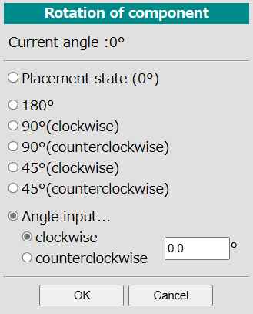

〇 Remove parts
With the [Remove] button selected, you can remove a part that does not have a pin or pen connected to it.
At this time, you can delete multiple parts in a row by holding down the Ctrl key and clicking.

〇 Panning the mechanism diagram screen
You can pan the screen by holding down the Alt key while dragging. The function to select and move a part of the screen is not implemented.

Running the Simulation

〇 Autorun
Press the " " and ▶ " triangle arrow buttons in the "Operation Menu" to rotate the powered part in each direction (reciprocating motion in ◀ the case of a power piston) and run the simulation.
During the simulation, you can stop the simulation by pressing the "■" button.
During the simulation, the slider displayed in the lower left corner of the screen allows you to switch the simulation speed to 5 levels.

〇 Manual execution
You can run the simulation manually by using the slider at the bottom of the screen.
By operating this slider, the power component can be operated for two cycles.

〇 "Position at the time of placement" button
By pressing the "Position at Placement" button, the power component can be returned to the angle at which it was placed. Press this button to erase the trajectory on the mechanism diagram.

